Field sketch

Draw two different field sketches of Cabramatta – one that shows the influence of Asian culture, and one which show hints of European culture. Ensure that you annotate your field sketch.
Field sketch 1: Influence of Asian culture
Field sketch 2: Influence of European culture
Environmental survey

Examine the following environmental criteria and make a judgement about the main street of Cabramatta. This is a subjective task and requires you to make a judgement about what you think of the location and how it makes you feel. For each item you need to give a rating from 1 to 5 (tick the box).

 | 1 | 2 | 3 | 4 | 5
Ugly |  |  |  |  |  | Beautiful
Smelly |  |  |  |  |  | Fresh
Chaotic |  |  |  |  |  | Ordered
Unhealthy |  |  |  |  |  | Healthy
Motionless |  |  |  |  |  | Moving
Poor |  |  |  |  |  | Rich
Boring |  |  |  |  |  | Interesting
Old |  |  |  |  |  | New
Weak |  |  |  |  |  | Strong
Noisy |  |  |  |  |  | Quiet
Hostile |  |  |  |  |  | Friendly
Dirty |  |  |  |  |  | Clean
Empty |  |  |  |  |  | Dense
Dark |  |  |  |  |  | Light
Tense |  |  |  |  |  | Relaxed
Pessimistic |  |  |  |  |  | Optimistic
Multicultural |  |  |  |  |  | Mono-cultural
Alternative |  |  |  |  |  | Mainstream
Unsafe |  |  |  |  |  | Safe
Monotonous |  |  |  |  |  | Colourful

Photographic evidence

During the day, take photographs that demonstrate:

- Cabramatta’s European heritage
- Cabramatta’s Vietnamese heritage
- Multiculturalism
- Different land use types.
Land use survey

As you walk along the streets annotate your map indicating which land uses are present. Before you begin, fill in the key below with colours or symbols to represent each land use.
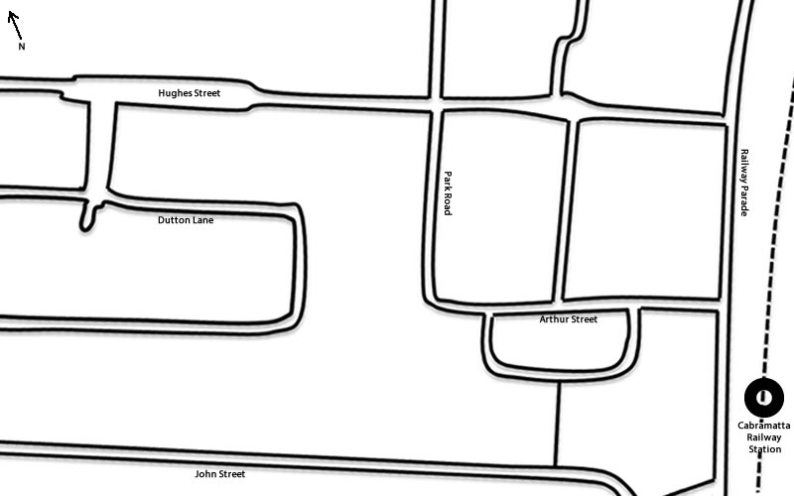
☐ Residential – low density
☐ Residential – medium/high density
☐ Commercial
☐ Industrial
☐ Recreational
☐ Agricultural
☐ Mixed use
☐ Transportation/Utilities

Reflection:
Describe how the different land uses are represented in discrete zones in the suburb of Cabramatta.
………………………………………………………………………………………………………………………………………………………………………………………………………………………………………………………………………………………………………………………………………………………………………………………………………………

Explain why the commercial and medium/high-density residential land uses are concentrated in particular areas.
………………………………………………………………………………………………………………………………………………………………………………………………………………………………………………………………………………………………………………………………………………………………………………………………………………

Questionnaire

- Do you live in Cabramatta?
Yes No

- If you live in Cabramatta, how long have you live here?
0-5 yrs 6-10 yrs 11-15 yrs 16-20 yrs 20+ yrs

- Do you have Vietnamese heritage (parents, grandparents, etc)?
Yes No

- Do you have Anglo-Australian heritage (parents, grandparents, etc)?
Yes No

- Were you born in Australia?
Yes No

- Do you work or have you worked in Cabramatta?
Yes No

- Do you shop in Cabramatta?
Never Sometimes Often Regularly

- What facilities are provided for the local community?
……………………………………………………………………………………………………………………………………………………………………………………………………………………………………………………………………………………………………………………………………………………………………………………………………………………………………………………………………………………………………………………
- How would you rate the facilities in your community
Poor Adequate Good Excellent

Shop analysis
(This is for you to complete. Examine 3 shopfronts).

- Name of shop. …………………………………………….
- Are there any signs in another language visible at the front of the shop or throughout? (Collect photographic evidence)
Yes No
- Does the architecture of the shop reflect Asian/Vietnamese culture?
Yes No
If yes, how? …………………………………………………………………
- What type of shop is it?
Restaurants/Cafe
Shopping (Retail)
Groceries
Entertainment

- Name of shop. …………………………………………….
- Are there any signs in another language visible at the front of the shop or throughout? (Collect photographic evidence)
Yes No
- Does the architecture of the shop reflect Asian/Vietnamese culture?
Yes No
If yes, how? …………………………………………………………………
- What type of shop is it?
Restaurants/Cafe
Shopping (Retail)
Groceries
Entertainment

- Name of shop. …………………………………………….
- Are there any signs in another language visible at the front of the shop or throughout? (Collect photographic evidence)
Yes No
- Does the architecture of the shop reflect Asian/Vietnamese culture?
Yes No
If yes, how? …………………………………………………………………
- What type of shop is it?
Restaurants/Cafe
Shopping (Retail)
Groceries
Entertainment

Cabramatta Library Presentation notes.

…………………………………………………………………………………………………………………………………………………………………………………………………………………………………………………………………………………………………….……………………………………………………………………………….…………………………………………………………………………………………………………………………………………………………………………………………………………………………………………………………………………………………………………………………….……………………………………………………………………………….…………………………………………………………………………………………………………………………………………………………………………………………………………………………………………………………………………………………………………………………….……………………………………………………………………………….…………………………………………………………………………………………………………………………………………………………………………………………………………………………………………………………………………………………………………………………….……………………………………………………………………………….…………………………………………………………………………………………………………………………………………………………………………………………………………………………………………………………………………………………………………………………….……………………………………………………………………………….…………………………………………………………………………………………………………………………………………………………………………………………………………………………………………………………………………………………………………………………….……………………………………………………………………………….…………………………………………………………………………………………………………………………………………………………………………………………………………………………………………………………………………………………………………………………….……………………………………………………………………………….…………………………………………………………………………………………………………………………………………………………………………………………………………………………………………………………………………………………………………………………….……………………………………………………………………………….…………………………………………………………………………………………………………………………………………………………………………………………………………………………………………………………………………………………………………………………….……………………………………………………………………………….…………………………………………………………………………………………………………………………………………………………………………………………………………………………………………………………………………………………………………………………….……………………………………………………………………………….…………………………………………………………………………………………………………………………………………………………………………………………………………………………………………………………………………………………………………………………….……………………………………………………………………………….…………………………………………………………………………………………………………………………………………………………………………………………………………………………………………………………………………………………………………………………….……………………………………………………………………………….…………………………………………………………………………………………………………………………………………………………………………………………………………………………………………………………………………………………………………………………….……………………………………………………………………………….…………………………………………………………………………………………………………………………………………………………………………………………………………………………………………………………………………………………………………………………….……………………………………………………………………………….…………………………………………………………………………………………………………………………………………………………………………………………………………………………………………………………………………………………………………………………….……………………………………………………………………………….…………………………………………………………………………………………………………………………………………………………………………………………………………………………………………………………………………………………………………………………….……………………………………………………………………………….…………………………………………………………………………………………………………………………………………………………………………………………………………………………………………………………………………………………………………………………….……………………………………………………………………………….…………………………………………………………………………………………………………………………………………………………………………………………………………………………………………………………………………………………………………………………….……………………………………………………………………………….…………………………………………………………………………………………………………………………………………………………………………………………………………………………………………………………………………………………………………………………….……………………………………………………………………………….…………………………………………………………………………………………………………………………………………………………………………………………………………………………………………………………………………………………………………………………….……………………………………………………………………………….…………………………………………………………………………………………………………………………………………………………………………………………………………………………………………………………………………………………………

